***NAME : Himanshu Dixit***

***ENROLL NO. : B64178***

***BATCH : B10***

***SOFTWARE DEVELOPMENT FUNDAMENTAL LAB-I(15B17CI171) Assignment Sheet (WEEK-8 PHASE-2)***

***Lab A***

**1.** Write a program in C using functions to display cube of a number.

***Solution:***

 #include<stdio.h>

cnum(int n)

{

int cube = n*n*n;

printf("Cube of number is %d",cube);

}

int main()

{

int n;

printf("Enter a number ");

scanf("%d",&n);

cnum(n);

return 0;

}

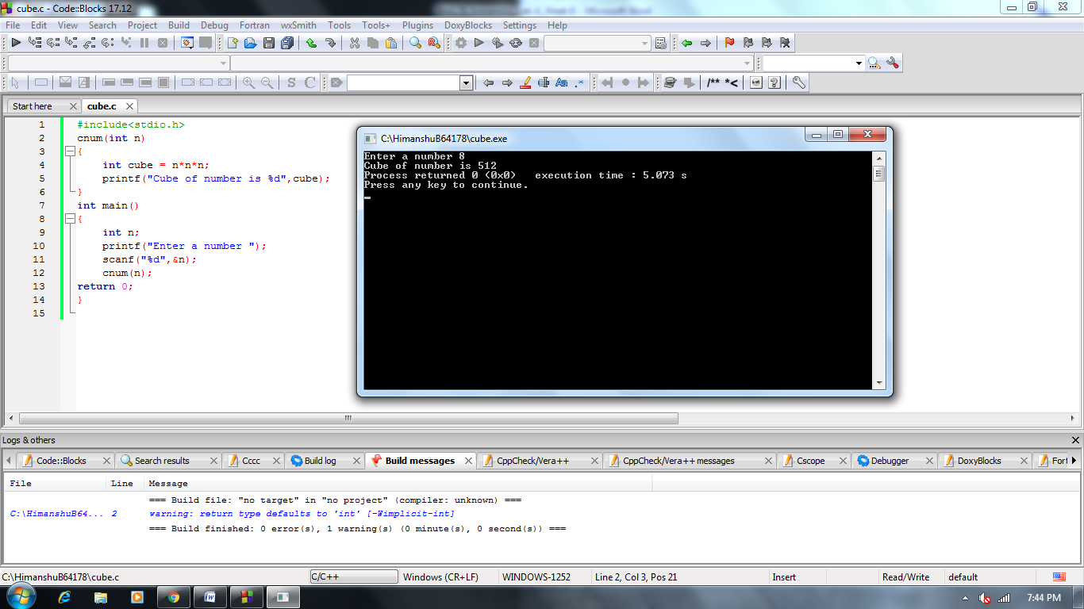

**2.** Write a program in C to display cube of first n numbers.

***Solution:***

#include<stdio.h>

void cnum(int n)

{

int i=1;

while(i<=n)

{

int cube = i*i*i;

printf("Cube of number %d is %d\n",i,cube);

i++;

}

}

int main()

{

int n;

printf("Cube of 1st N number ");

scanf("%d",&n);

cnum(n);

return 0;

}

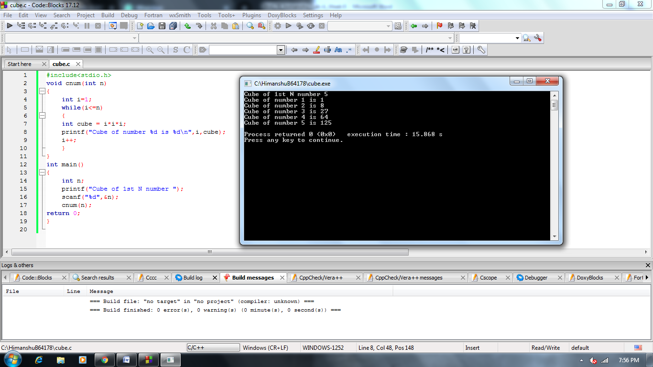

**3.** Write a program in C to convert decimal number to octal number using the function.

***Solution:***

#include<stdio.h>

void conv(int n)

{

int i;

int a[10];

for(i=0;n>0;i++)

{

a[i]=n%8;

n=n/8;

}

int k=i-1;

printf("Octal convert is ");

for(i=k;i>=0;i--)

printf("%d",a[i]);

}

int main()

{

int n;

scanf("%d",&n);

conv(n);

return 0;

}

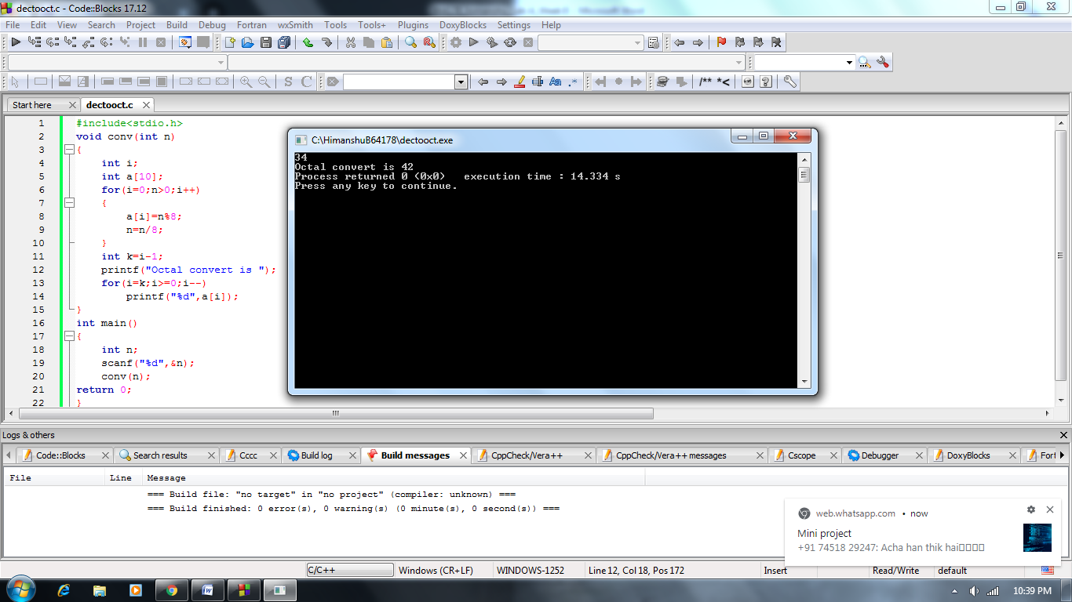

**4.** Write a program in C to add two complex numbers using function.

***Solution:***

#include<stdio.h>

void add(int r,int i,int r1,int i1)

{

int sum=0,sum1=0;

sum=r+r1;

sum1=i+i1;

printf("(%d + i%d) + (%d + i%d) = %d + i%d",r,i,r1,i1,sum,sum1);

}

int main()

{

int r,i,r1,i1;

printf("Enter real and imaginary part a + i b = ");

scanf("%d%d",&r,&i);

printf("Enter real and imaginary part a1 + i b1 = ");

scanf("%d%d",&r1,&i1);

add(r,i,r1,i1);

return 0;

}

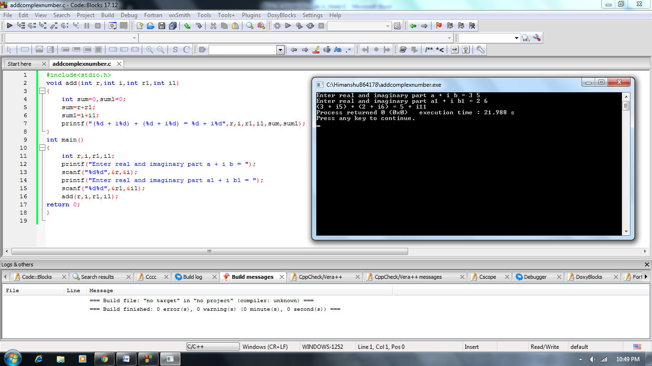

**5.** Write a program in C to compute Fibonacci series for a range using function.

***Solution:***

#include<stdio.h>

void series(int n)

{

int a=0,b=1,sum;

if(n==1)

printf("%d",a);

if(n>=2)

{

printf("%d %d ",a,b);

while(n>2)

{

sum=a+b;

a=b;

b=sum;

printf("%d ",b);

n--;

}

}

}

int main()

{

int n;

scanf("%d",&n);

series(n);

return 0;

}

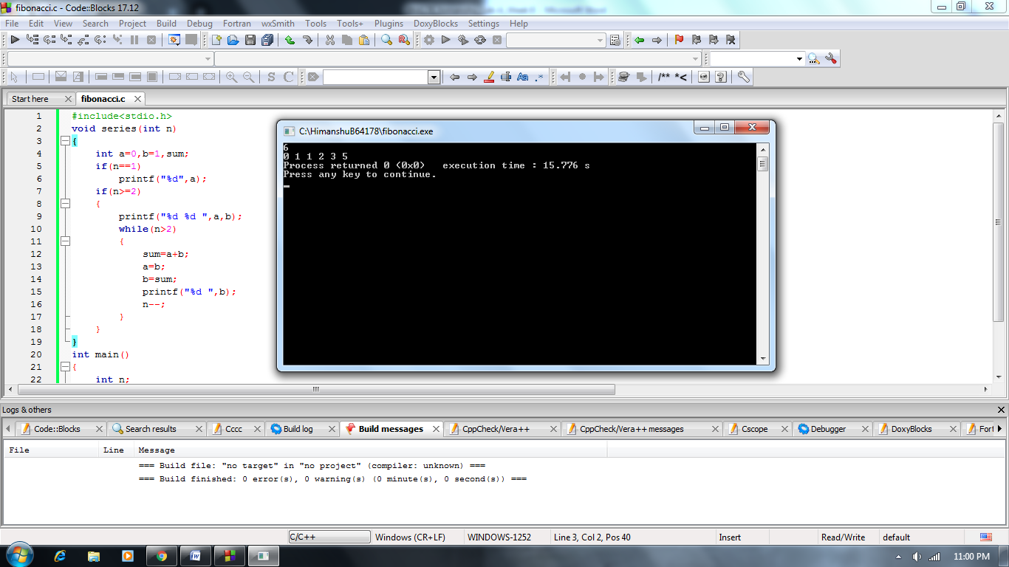

**6.** Write a program in C to check whether a number can be expressed as sum of two prime numbers.

***Solution:***

#include<stdio.h>

void check(int n)

{

int k;

for(int i=1;i<=n/2;i++)

{

k=cprime(i,n-i);

}

if(k==0)

printf("It can be expressed as sum of two prime numbers");

else

printf("It cannot be expressed");

}

int cprime(int a,int b)

{

int x=0,y=0;

for(int i=2;i<=a/2;i++)

if(a%i==0)

x=1;

for(int i=2;i<=b/2;i++)

if(b%i==0)

y=1;

if(x==0&&y==0)

return 0;

else

return 1;

}

int main()

{

int n;

scanf("%d",&n);

check(n);

}

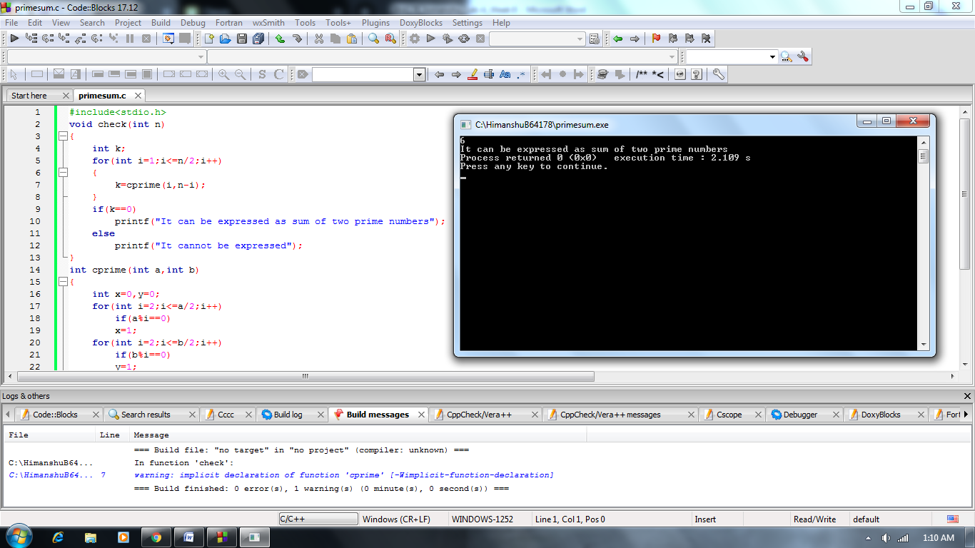

**7.** Write a program in C to create a calculator with basic operations using functions.

***Solution:***

#include<stdio.h>

void add(int a,int b)

{

int r;

r=a+b;

printf("%d",r);

}

void sub(int a,int b)

{

int r;

r=a-b;

printf("%d",r);

}

void mul(int a,int b)

{

int r;

r=a*b;

printf("%d",r);

}

void div(int a,int b)

{

float r;

r=a/b;

printf("%f",r);

}

int main()

{

int a,b;

char c;

printf("enter which operation you want to do :\n(a) addition\n(s) subtraction\n(m) multiplication\n(d) divide\n");

scanf("%c",&c);

printf("enter two number ");

scanf("%d%d",&a,&b);

switch(c)

{

case 'a':add(a,b);

break;

case 's':sub(a,b);

break;

case 'm':mul(a,b);

break;

case 'd':div(a,b);

}

return 0;

}

